AI FitTrack Project Development
  - Phase 5

This implementation document explains the modules, dependencies, API behavior and source-level evidence present in the uploaded backend ZIP.
Field | Value
Project | AI FitTrack
Submission | SmartBridge Naan Mudhalvan
Team ID | SWTID-2026-8100
Team size | 4
College | DRBCCC Hindu College
Department | B.Sc. Computer Science with Artificial Intelligence
Academic Year | 2024–2027
Faculty Guide | Prof. D Saraswathy
Submission Date
Team Leader | Parthiban M (NM ID: 28538B1DB05060E8D804CDAA88169909, Reg: 222401226)
Team Members | Naveen J (NM ID: 53C2DC1753C6DFDAF8649841B4630C80, Reg: 222401223); Nidesh N S (NM ID: FDE55A8DA9135F6AB7347C01AD1B8A17, Reg: 222401224); Nithish Kumar P (NM ID: BFBD9AD8CEC72229F374877DB82CC0B8, Reg: 222401225)
Project scope | Backend-only REST API
Technology | Node.js, Express.js, MongoDB, Mongoose, JWT and Google Gemini AI
Source baseline | Latest uploaded backend ZIP and supplied verification evidence
Document status | Submission-ready verified technical documentation with complete academic details

Prepared for academic evaluation. Secrets, credentials, private environment files and unverified claims are excluded.

Document contents
1. Implementation baseline
2. Module map
3. Setup and execution
4. Authentication
5. Workout module
6. Gemini module
7. Implementation evidence

Implementation baseline
The uploaded backend contains a root README, server package, dependency lockfile, safe environment example, models, routes, controllers, middleware, services, validation utilities, automated tests and a Postman collection. The archive contains no private .env file.
Runtime dependency | Uploaded version range | Purpose
express | ^5.2.1 | HTTP routing and middleware
mongoose | ^9.10.1 | MongoDB object-document mapping
jsonwebtoken | ^9.0.3 | JWT signing and verification
bcryptjs | ^3.0.3 | Password hashing and comparison
@google/genai | ^2.24.0 | Gemini content generation
cors | ^2.8.6 | Configurable cross-origin access
dotenv | ^18.0.2 | Local environment loading
supertest | ^7.2.2 | HTTP integration tests
mongodb-memory-server | ^11.3.0 | Isolated automated MongoDB testing

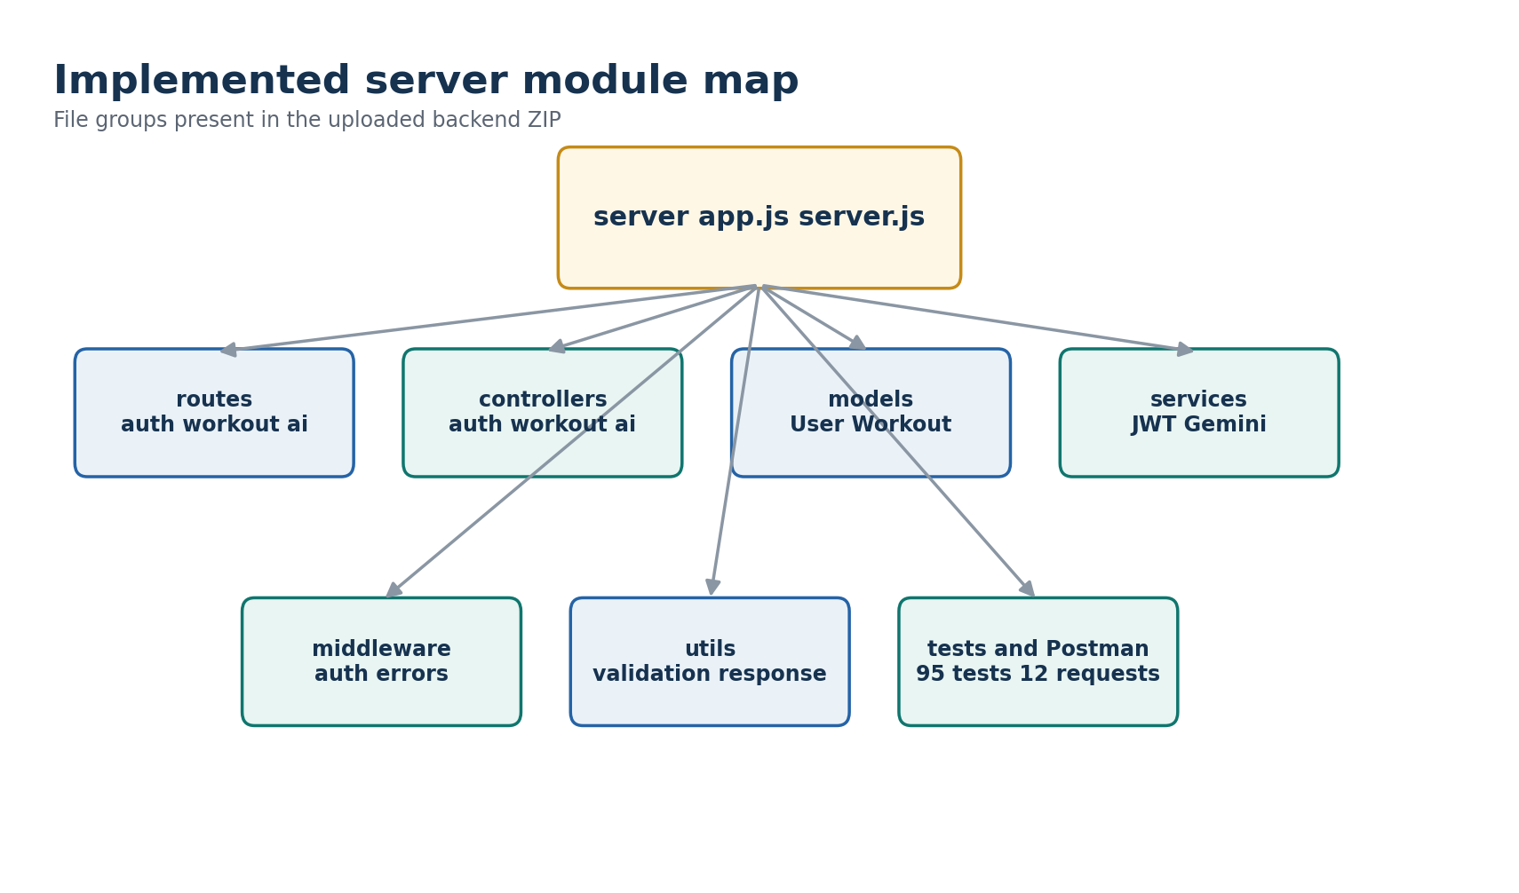
Figure 1 Uploaded server modules and verification assets

Setup and execution
- Install Node.js 20 or later and MongoDB access.
- Open the server folder and run npm install or npm ci.
- Copy .env.example to .env and enter private values locally. Never commit that file.
- Run npm start for the production-style start command or npm run dev for nodemon.
- Confirm GET /api/health returns HTTP 200 before testing feature routes.
cd server
npm ci
# create server/.env locally from .env.example
npm start
# health: GET http://localhost:5000/api/health

Authentication implementation
Registration validates and normalizes input, checks for an existing email, creates a User document and returns a signed token with a safe user object. Login explicitly selects the stored password hash only for comparison and uses the same generic unauthorized message for an unknown email or incorrect password.
// authMiddleware.js - verified request identity
decoded = verifyToken(token);
const user = await User.findById(decoded.sub || decoded.id);
req.user = user;
req.userId = user._id.toString();

Workout implementation
All workout routes apply protect before the controller. Create assigns the owner from req.user._id. Read, update and delete operations combine the workout identifier with the authenticated owner. Search escapes user-entered regular-expression characters, canonicalizes category values and uses explicit UTC day boundaries.
// workoutController.js - ownership is part of the database query
const workout = await Workout.findOne({
_id: id,
user: req.user._id
});

Gemini implementation
The AI controller validates inputs and enforces a per-user, per-process request limit. The service requests structured JSON from Gemini, applies a per-attempt timeout, retries only transient failures, respects Retry-After within a bounded delay and converts provider failures into safe application errors.
Endpoint | Input | Structured output
workout-recommendation | age, fitnessGoal, experienceLevel or experience | Plan, weeklySchedule, experience guidance, tips, recovery, safety and motivation
fitness-insights submitted | totalWorkouts, averageWorkoutDuration or averageDuration, totalCaloriesBurned | Performance, consistency, improvement, motivation and progress summary
fitness-insights database | useDatabaseStats true | Same insight structure using only the authenticated user's MongoDB records

API implementation catalog
Method | Endpoint | Access | Purpose | Main statuses
GET | /api/health | Public | Service health and runtime metadata | 200
POST | /api/auth/register | Public | Create user and issue JWT | 201, 400, 409
POST | /api/auth/login | Public | Verify credentials and issue JWT | 200, 400, 401
GET | /api/auth/email-available | Public | Check normalized email availability | 200, 400
GET | /api/auth/profile | JWT | Return authenticated user profile | 200, 401
POST | /api/workouts | JWT | Create an owner-scoped workout | 201, 400, 401
GET | /api/workouts | JWT | List history and optional filters | 200, 400, 401
GET | /api/workouts/search | JWT | Search by name, category or UTC date | 200, 400, 401
GET | /api/workouts/:id | JWT | Read one owned workout | 200, 400, 404
PUT | /api/workouts/:id | JWT | Update allowed workout fields | 200, 400, 404
DELETE | /api/workouts/:id | JWT | Delete one owned workout | 200, 400, 404
POST | /api/ai/workout-recommendation | JWT | Generate structured workout plan | 200, 400, 429, 5xx
POST | /api/ai/fitness-insights | JWT | Generate submitted or database-derived insights | 200, 400, 429, 5xx

Source-to-feature evidence
Feature | Primary source files | Evidence basis
Server lifecycle | server.js, config/db.js | Connect before listen; graceful shutdown; meaningful connection errors.
API gateway | app.js | CORS, body parsing, health, route mounting, 404 and centralized errors.
Auth | authRoutes.js, authController.js, User.js, jwtService.js, authMiddleware.js | Register, login, profile and missing-token live records.
Workouts | workoutRoutes.js, workoutController.js, Workout.js, workoutValidation.js | Eight live CRUD/search records and 12 workout tests.
Gemini | aiRoutes.js, aiController.js, geminiService.js, aiValidation.js | Three live AI records and AI/retry automated tests.
Standard errors | ApiError.js, errorMiddleware.js, response.js | 400, 401, 404, 409 and AI error tests.
Manual API run | postman/AI-FitTrack.postman_collection.json | 12 ordered requests across health, auth, workouts and AI.

Implementation evidence limits
- The supplied evidence contains sanitized text captures rather than evaluator-facing screenshots.
- The evidence records an earlier delete response with data:null, while the uploaded controller currently returns the deleted workout object inside data.workout. The delete behavior is verified, but the exact current payload should be re-captured.
- The submitted-statistics evidence labels statsSource as manual, while the uploaded controller sets submitted. The AI behavior is verified, but that response label should be re-captured from the frozen ZIP.
- The current workspace did not reinstall dependencies, so no new test outcome is claimed here; all pass counts are taken from the supplied verification records.

Items requiring student confirmation
Pending item | What to provide
Repository | Insert the final public GitHub repository URL after upload.
Deployment | Insert the deployed API base URL if the evaluator requires a hosted demonstration.

